September 2020

New Enrolment Financial Contract and Registration 2020-2021

________________________________________________________________
Primary Payee Phone Number Email address

Financial Agreement: I agree to pay the appropriate tuition rate and an annual $100 registration fee for each said child. I have indicated the payment plan below by marking the appropriate box(es) and listing hours needed below.

Full Day Monthly Tuition  (Includes preschool) | 2 Day (T,Th) | 3 Day (M,W,F) | 5 Day
Infant 6 Weeks- 12 mo | □ $870 | □ $1040 | □ $1395
Toddler  12 mo- 30 mo | □ $540 | □ $765 | □ $1100
Over 30 mo (Not Potty Trained) | □ $515 | □ $705 | □ $1000
Preschool and Pre-K  (3 yrs- 5 yrs) | □ $370 | □ $535 | □ $820
School Age Daily Rate | Daily
Full Day | $40
Before Care Only | $15
After Care Only | $25
Before and After Care | $35

Half Day Preschool and Pre-K  9:00am – 12:00pm | 2 Day  T, TH | 3 Day  M, W, F | 5 Day  M-F
Monthly Rate | □ $260 | □ $350 | □ $445

*School-age families, full day care on “No School” days will be based upon availability.
* Weekly Tuition is Available for extended breaks.

Student's Name | Start Date | Mon | Tues | Weds | Thurs | Fri | Rate of Pay

* A 10% discount applies to each additional child
Payment: Payment is due by the 10th of each month. A $5 fee will be added to your bill for every day the bill is not paid. Sonshine will provide monthly statements at the end of each month. We accept cash and checks. $35 will be charged for all returned checks. Sonshine has the right to refuse service if your bill is not paid and will not hold your child’s spot. If you are terminating childcare, two weeks’ notice is expected or a $70 fee will be applied.
Absences: Our operation is dependent upon your tuition payments; therefore there are no billing adjustments for absences, such as illness, weather, or personal plans. A vacation credit of 14 days is available for full time tuition families and must be requested two weeks in advance by written notice.
Late Pick-Up: There is a $2 a minute fee for each child in our care past 6:00pm. The late fee will need to be paid the next day.
Holidays/ Closures: The center will be closed for the following holidays: New Years Eve, New Years Day, Independence Day, Thanksgiving Thursday & Friday, Christmas Eve, Christmas Day, Labor Day and Memorial Day, and a few in-service days over the Summer. (Should the daycare close on any additional days, appropriate notice will be given to the parents).
Drop-in Care: Drop-ins are allowed on a space available basis only. Parents are required to call or message on BrightWheel prior to drop-off to inquire about available space.

__________________________________________________________________________________________________________________
Parent/Guardian/Payee Signature Date

Sonshine Christian Daycare and Preschool
11208 N.E. Hazel Dell Ave.
Vancouver, WA. 98685
Phone (360) 573-7174
sonshinedaycare@gmail.com
sonshineschoolvancouver.org

Personal Information:
Child’s Name: Child’s birth date:
Nicknames used: □ Male □ Female

Mother’s Name: Father’s Name:
Mother’s Phone #: Father’s Phone #:

□ Married □ Divorced □ Single
Mailing Address:

Email Address:

Please list persons authorized to pick your child up:
Name and relationship to the child:
Phone #:
Address:

Name and relationship to the child:
Phone #:
Address:

Name: _______________________________ Phone: _________________

Emergency Contact:
Name and relationship to the child:

Address:

Phone #:

I agree to all the policies laid out in the Sonshine Christian Daycare Parent Handbook.

Parents Signature: ____________________________________________ Date: ________________

Additional Authorized Pick Ups

Name and relationship to the child:
Phone #:
Address:

Name and relationship to the child:
Phone #:
Address:

Name and relationship to the child:
Phone #:
Address:

Name and relationship to the child:
Phone #:
Address:

Name and relationship to the child:
Phone #:
Address:

Name and relationship to the child:
Phone #:
Address:

Limited Power Of Attorney
For
Emergency Medical Care Authorization

For: ________________________________________________________________________________
(First Name) (Middle name) (Last name)

I ______________________(natural parent or legal guardian) hereby give permission that my child ________________________, may be given emergency treatment to include first aid and CPR by a qualified child care staff member at Sonshine Christian Daycare and Preschool. I further authorize and consent to medical, surgical and hospital care, treatment and procedures to be performed for my child by my child’s regular physician, or when deemed immediately necessary or advisable by the physician to safeguard my child’s health and I cannot be contacted. I waive my right of informed consent to such treatment. I also give permission for my child to be transported by ambulance or aid car to an emergency center for treatment. I accept all financial responsibility for necessary treatment and services.
Primary phone number:
Home address:

Insurance Company: ______________________________________________________________

Plan or Group Number: _________________ Policy/Membership # ______________________

Employer: ________________________________________________________________________
(Name of Company) (Phone)

__________________________________________________________________________________
(Address of Employer)

Allergies: ________________________________________________________________________

Other: ____________________________________________________________________________

Signature: ________________________________________________________________________

Relationship to Student: ___________________________________________________________

Date: _____________________________________________________________________________

I have received information regarding your childcare facility’s out-of-area emergency contact. I understand that your childcare facility has established policies to respond appropriately to a disaster.

Signature: ___________________________________________ Date: ___________________

Please provide the following information for our emergency records:

Child’s name: __________________________________________________________________

Child’s out-of-area contact (100+ miles away) Name, Phone, and Address:
___________________________________
___________________________________
___________________________________

Emergency contact (friend, family or loved-one) Name, Phone, and Address:
__________________________________
__________________________________
__________________________________

Local contact (the nearest acquaintance) Name, Phone, and Address:
___________________________________
___________________________________
___________________________________

We encourage you to familiarize yourself with the disaster plans and policies established for our childcare facility. You will find the plans in the Parent Handbook.

Please tear off and keep the following portion for your home records

Dear Parent or Family,

During a disaster, communication may become challenging. Often it is easier to contact an out-of-area phone number. Our facility is establishing an out-of-area number to relay information throughout a disaster. Please put this number in a convenient and accessible place so that you are able to get information about your child, should local calling become challenging.

Our out-of-area contact is:

Sonshine Christian Daycare
11208 N.E. Hazel Dell Ave.
Vancouver, WA. 98685
(360) 573-7174
sonshinedaycare@gmail.com
sonshineschoolvancouver.org

Child’s Name: ________________________________________________________________________

□ Is physically and emotionally able to participate in an active daycare program
□ Is not physically and emotionally able to participate in an active daycare program

Additional comments:

Date of most recent physical/Well Child: ________________________________________________

Does this child have any specific health problems of which the staff should be made aware?
(i.e., vision, hearing loss, allergies, etc…)

Physician Information:
Name:
Address:

Phone #:

Parent Signature: __________________________________________ Date: _____________________

Sunscreen Authorization Form

The staff at Sonshine Christian Daycare/Preschool needs permission from a parent in order to apply sunscreen to your child. We advise and assume that sunscreen will be applied prior to bringing your child to school; however, we understand that another application may be necessary throughout the day. Sonshine Christian Daycare/Preschool will provide sunscreen.

I give Sonshine Christian Daycare/Preschool permission to apply sunscreen on my son/daughter _____________________________________________.
Child’s name

Any known adverse reactions_________________________________________________________

Parent Instructions:

______________________________________________________ ________________________
Parent Signature Date

Photo Permission Slip

Sonshine Christian Daycare & Preschool would like your permission to use photographs on our website, our Facebook page, in the newsletter, in the brochure and/or on our bulletin boards. Pictures would be selected to highlight activities during preschool, our classroom environments, and/or program events. We will never reference your child by name or provide any specific information regarding your child. The pictures will only be used by Sonshine Christian Daycare & Preschool to show the many ways our children have fun while participating in daycare!

Please take a moment to let us know your preferences regarding our use of photos of your children:

_____YES. I grant permission to use photos of my child on Sonshine Christian Daycare & Preschool website, our Facebook page, brochure, bulletin boards, and /or newsletters.

-OR-

_____ NO. Please do NOT take or use any photos of my child.

Child(ren)’s Name(s) (PLEASE PRINT):

_______________________________________________________________________________

_______________________________________________________________________________

_______________________________________________________________________________

Parent/Guardian’s Name (PLEASE PRINT):

_______________________________________________________________________________

Parent/Guardian’s Signature:

_______________________________________________________________________________

Date: ______________________

For questions or concerns about this form, please feel free to contact The Director.

Animals on Premise Policy
Sonshine Christian Daycare
Updated 03/6/14

I, (Print Name)__________________________, have read and understand the Child Care Center’s Animal on Premise Policy. (See Parent Handbook)

Child’s Name_____________________________

( ) Is allowed to interact with animals in small supervised groups.

( ) Is NOT allowed to interact with animals at any time.

_________________________________ ____________________
Parent/Guardian Signature Date

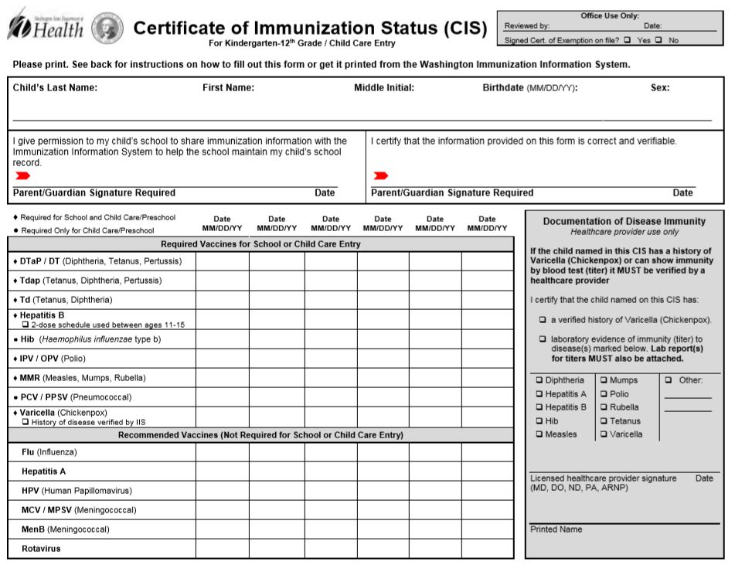
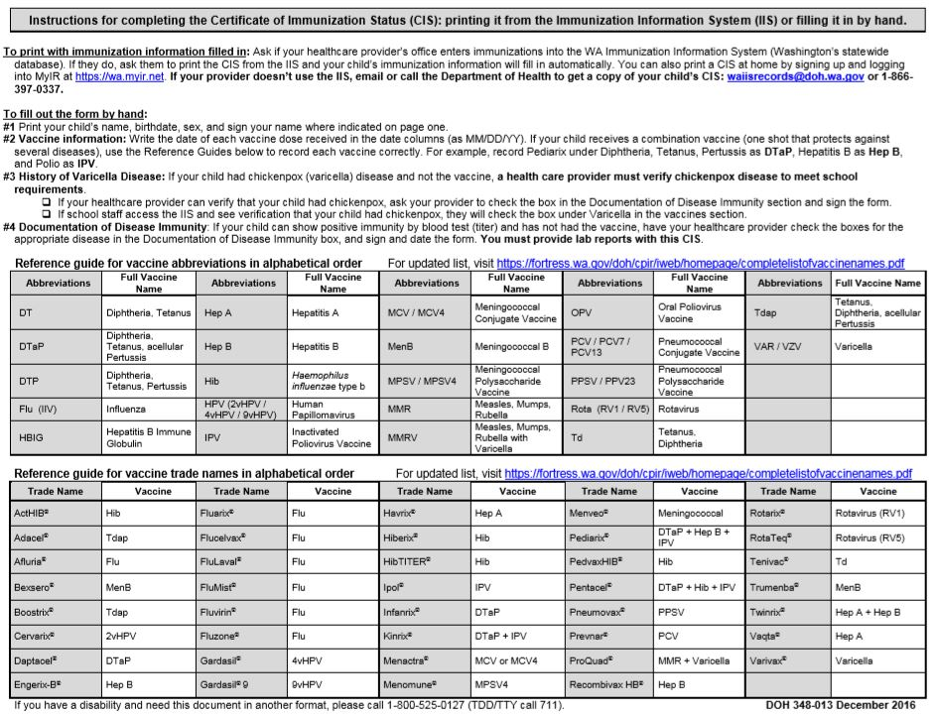
All About Me
Please attach a photo, or ask your child to draw a picture here

Child's Name:__________________________________

The best way to reach my family is:
_______________________________________________

The best time to reach my family is: (please circle)

Morning Afternoon Evening Weekend

The best phone number/ e-mail to reach my family is:__________________________________

The name I like to be called is:________________________________________________

My favorite activities/ things are:_________________________________________________________________________
_____________________________________________________________________________

The family members or friend I enjoy spending time with, and what we like to do:
_______________________________________________________________________________________________________________________________________________________________________________________________________________________________________

What helps me to feel more comfortable in new social situations:_________________
_____________________________________________________________________________

How I respond to new situations or challenges:__________________________________
_____________________________________________________________________________

I learn new things best when: (please give an example)_______________________________________________________________________________________________________________________________________________________________________________________________________________________________

I live with: (please list the family in the houshold)______________________________________________________________________________________________________________________________________________________________________________________________________________________________

We speak the following languages in our house:_________________________________
_____________________________________________________________________________

When I am frustrated or sad this helps me feel better:____________________________
_______________________________________________________________________________________________________________________________________________________________________________________________________________________________________

My favorite foods are:_________________________________________________________

I do not like: (any foods or activities that your child should avoid) ________________
__________________________________________________________________________________________________________________________________________________________

Other things I want you to know about me:
(Notes to the teacher)
________________________________________________________________________________________________________________________________________________________________________________________________________________________________________________________________________________________________________________________

